**Java Source File Structure and First Java Program**

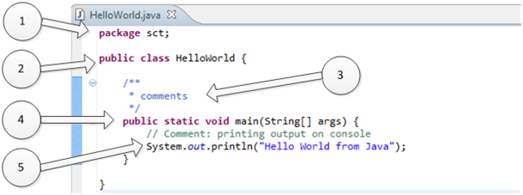

**1.“package sct”:**

It is package declaration statement. The package statement defines a namespace in which classes are stored. The package is used to organize the classes based on functionality. If you omit the package statement, the class names are put into the default package, which has no name. Package statement cannot appear anywhere in the program. It must be the first line of your program or you can omit it.

**2.“public class HelloWorld”:**

This line has various aspects of java programming.

**a.** public: This is access modifier keyword which tells compiler access to class. Various values of access modifiers can be public, protected,private or default (no value).

**b.** class: This keyword used to declare a class. Name of class (HelloWorld) followed by this keyword.

**3. Comments section:**

We can write comments in java in two ways.

**a.** Line comments: It starts with two forward slashes (//) and continues to the end of the current line. Line comments do not require an ending symbol.

**b.** Block comments start with a forward slash and an asterisk (/*) and end with an asterisk and a forward slash (*/).Block comments can also extend across as many lines as needed.

**4. “public static void main (String [ ] args)”:**

Its method (Function) named main with string array as an argument.

**a.** public : Access Modifier

**b.** static: static is a reserved keyword which means that a method is accessible and usable even though no objects of the class exist.

**c.** void: This keyword declares nothing would be returned from the method. The method can return any primitive or object.

**d.** Method content inside curly braces. { } asdfla;sd

**5. System.out.println("Hello World from Java") :**

**a.** System: It is the name of Java utility class.

**b.** out:It is an object which belongs to System class.

**c.** println: It is utility method name which is used to send any String to the console.

**d.** “Hello World from Java”: It is String literal set as argument to println method.

**Steps to Compile and Run your first Java program**

**Step 1:** Open a text editor and write the code as above.

**Step 2:** Save the file as Hello.java

**Step 3:** Open command prompt and go to the directory where you saved your first java program assuming it is saved in C:\

**Step 4:** Type javac Hello.java and press Return to compile your code. This command will call the Java Compiler asking it to compile the specified file. If there are no errors in the code the command prompt will take you to the next line.

**Step 5:** Now type java Hello on command prompt to run your program.

**Step 6:** You will be able to see **Hello world program** printed on your command prompt.

**From Eclipse run and build the program**

